Navigate360 Comprehensive Training Manual
Notre Dame of Maryland University
Student Success Center
Advisor & Student Success Staff Guide
Platform: Navigate360 by EAB
Purpose: Training and onboarding manual for new staff

Table of Contents
1. Platform Overview
2. Navigate Dashboard Overview
3. Searching for Students
4. Viewing Assigned Students
5. Setting Appointment Availability
6. Scheduling Appointments
7. Advising Workflow Guide
8. Adding Notes
9. Issuing Alerts and Progress Reports
10. Messaging Students
11. Helping Students Register for Courses
12. Reporting and Analytics
13. Best Practices for Advisors
14. Facilitator Training Guide
15. Advisor Quick Reference Sheet

1. Navigate Dashboard Overview
Navigate360 is a student success platform that allows advisors, faculty, and staff to track student engagement, schedule appointments, document interactions, and coordinate support services across campus.

Staff Home Dashboard Example
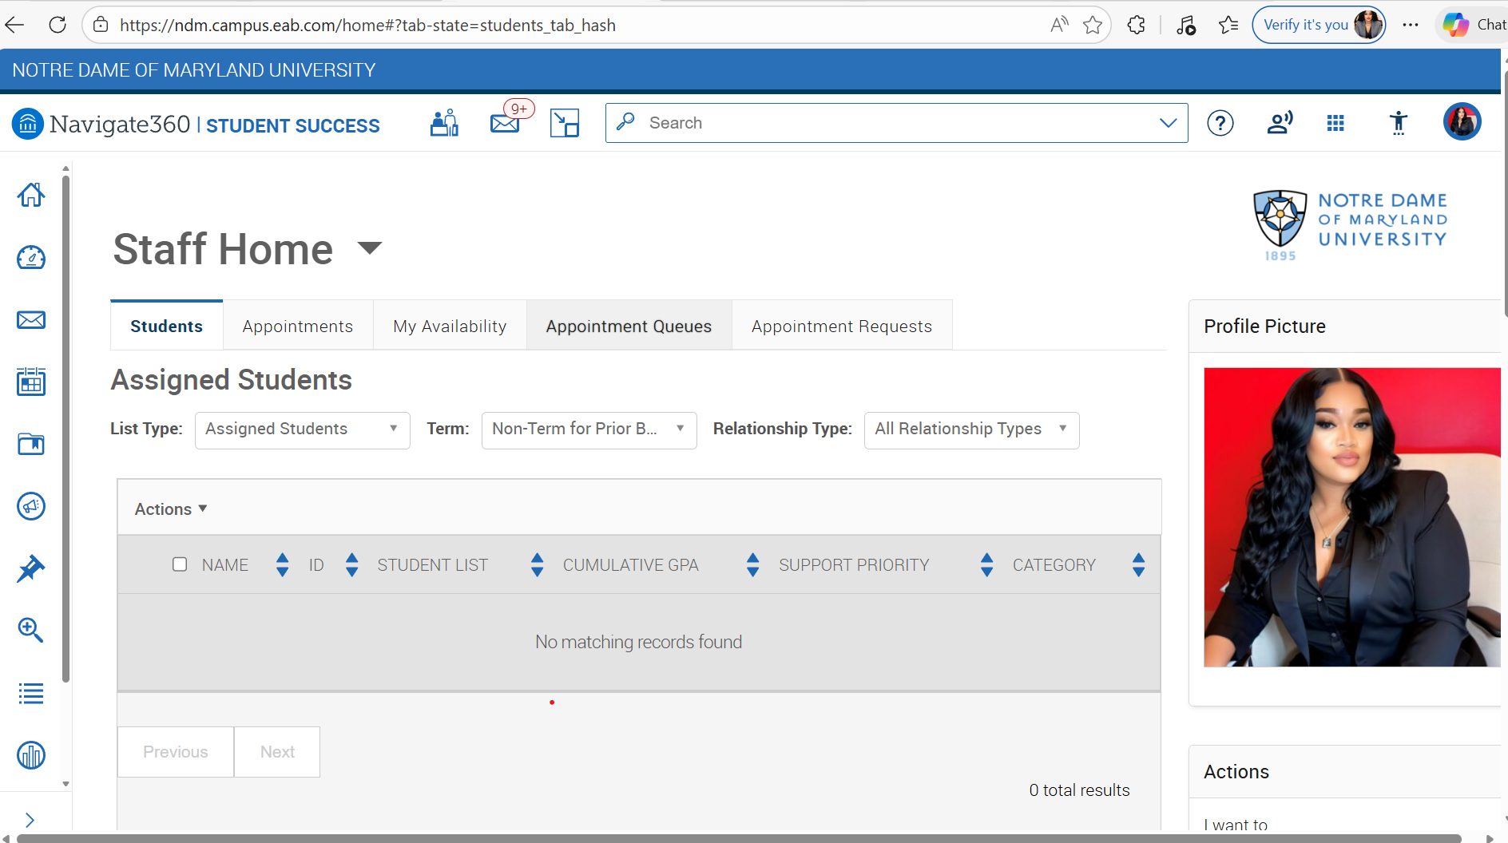
Example of the Navigate360 Staff Home dashboard used by advisors and student success staff.

2. Searching for Students
- Use the search bar at the top of the dashboard.
- Enter the student's name, ID, or email.
- Click the student result to open the full profile.
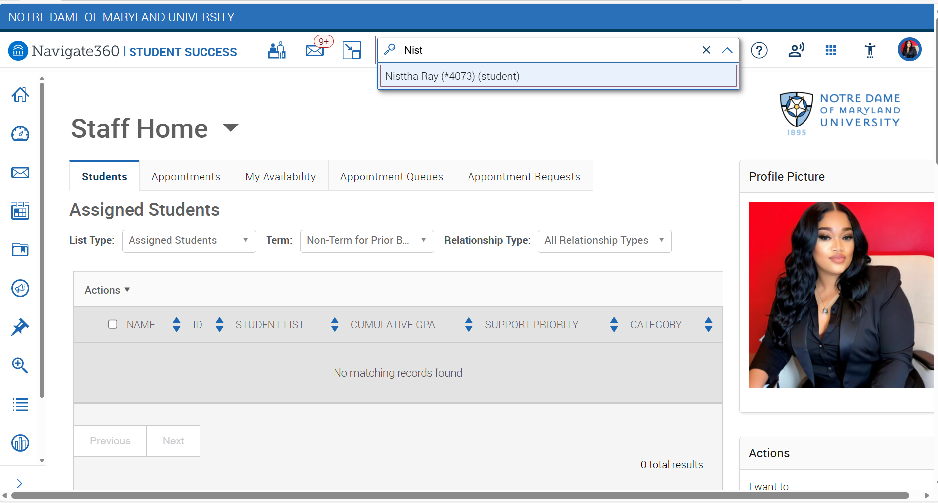
- What you will see
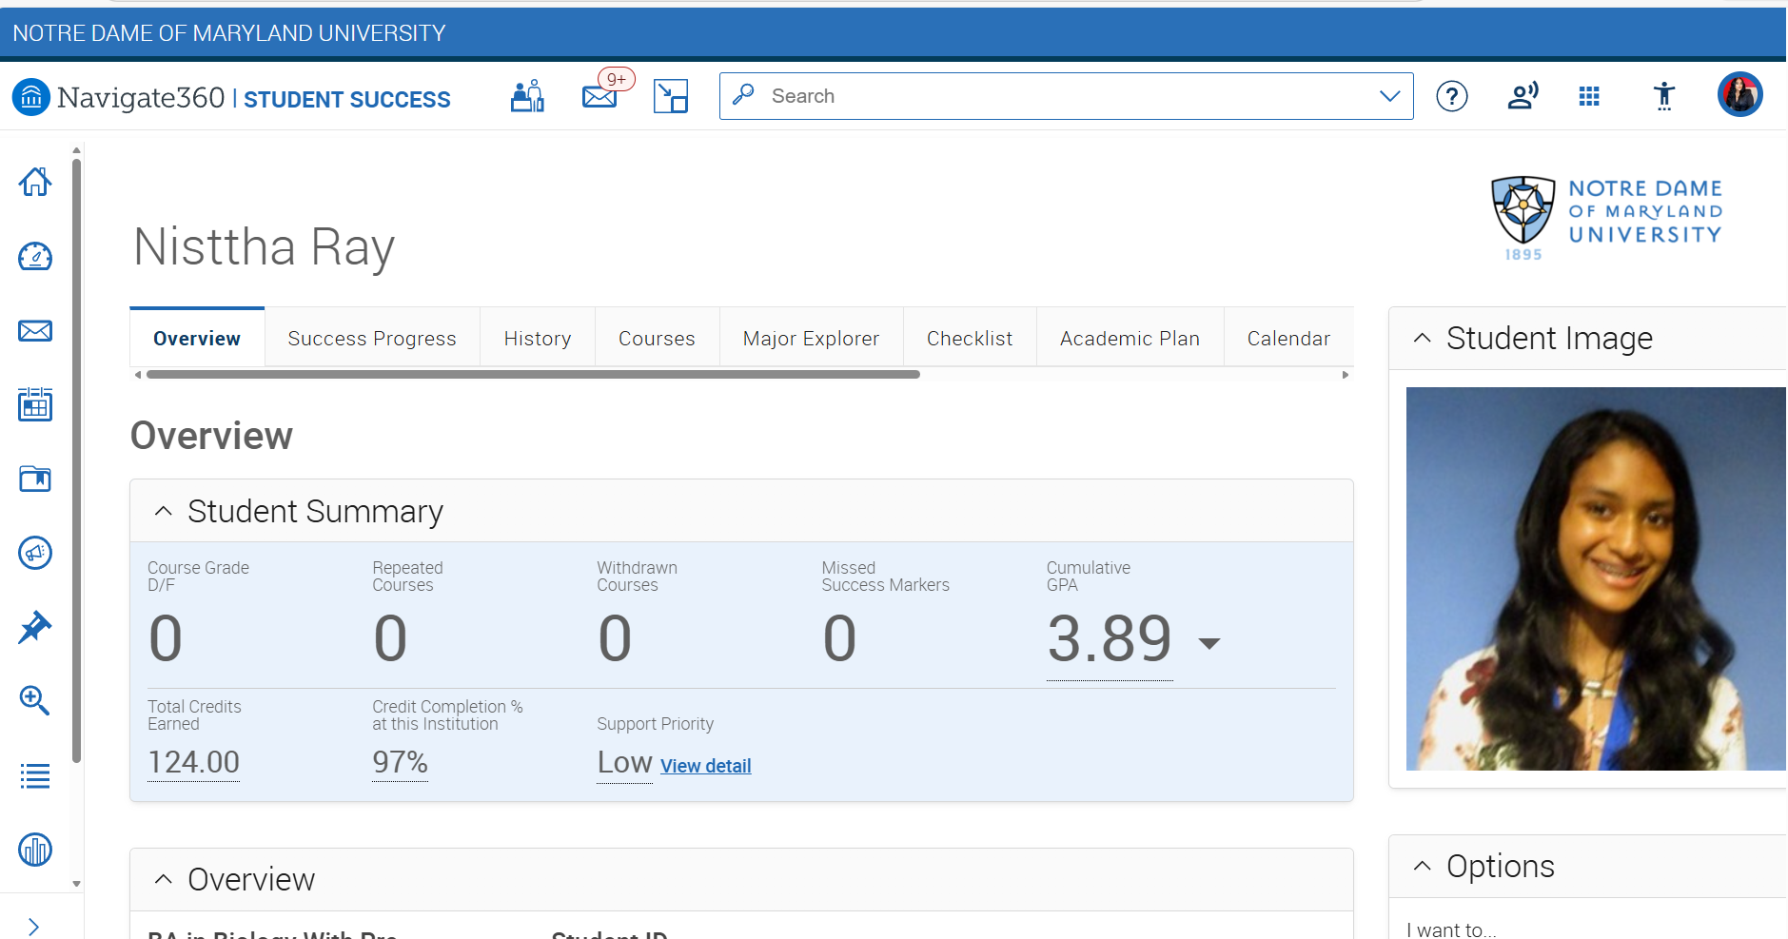

3. Viewing Assigned Students
- If you have multiple roles in Navigate, switch between roles (Student, Staff, Professor)
- Click the 'Students' tab on the Staff Home page.
- Select 'Assigned Students' from the list type menu.
- Use filters to narrow by term or relationship type.
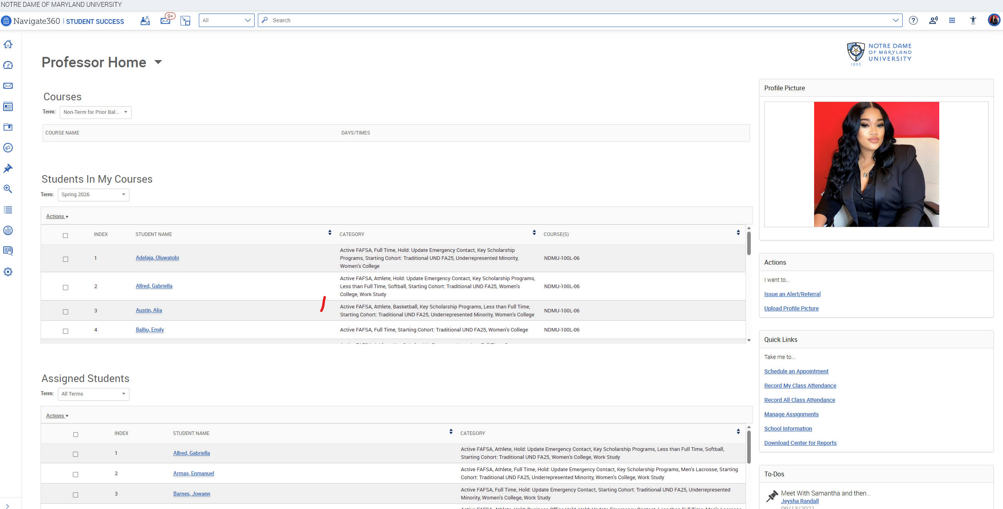

4. Setting Appointment Availability
- Click the 'My Availability' tab.
- Select 'Add Time'.
- Choose days, times, location, range, and appointment type.
- Save availability to allow students to book meetings.
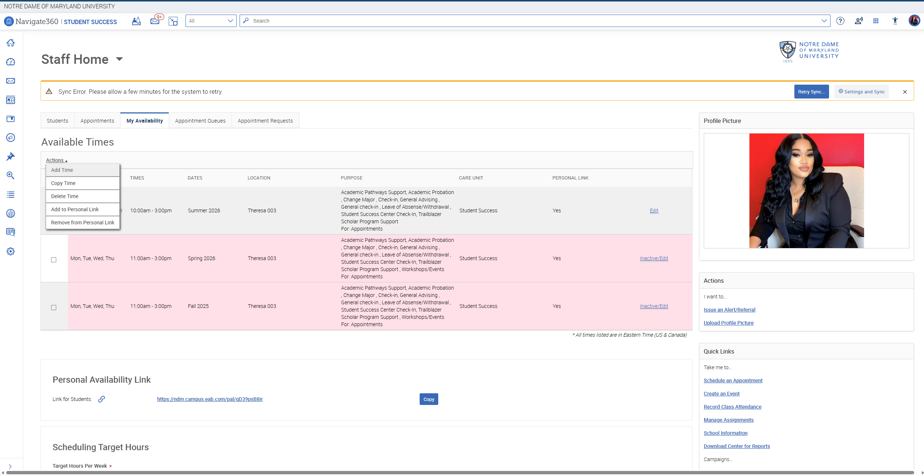

5. Scheduling Appointments
- Open the student's profile.
- Click 'Schedule Appointment '.
- Choose the Care Unit, Location, Service, Course if applicable, date & time.
- Save to confirm the appointment.
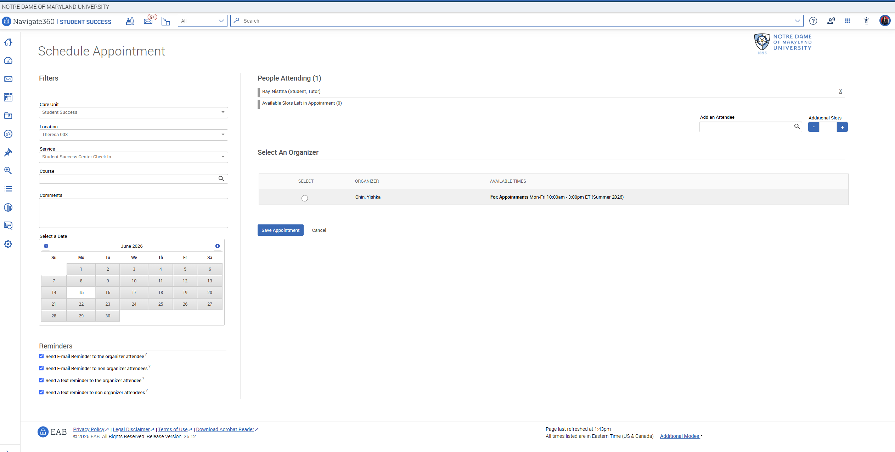

6. Adding Advising Notes
- Open the student's profile.
- Click 'Add Note'.
- Choose the appropriate note category.
- Document the advising conversation and save.
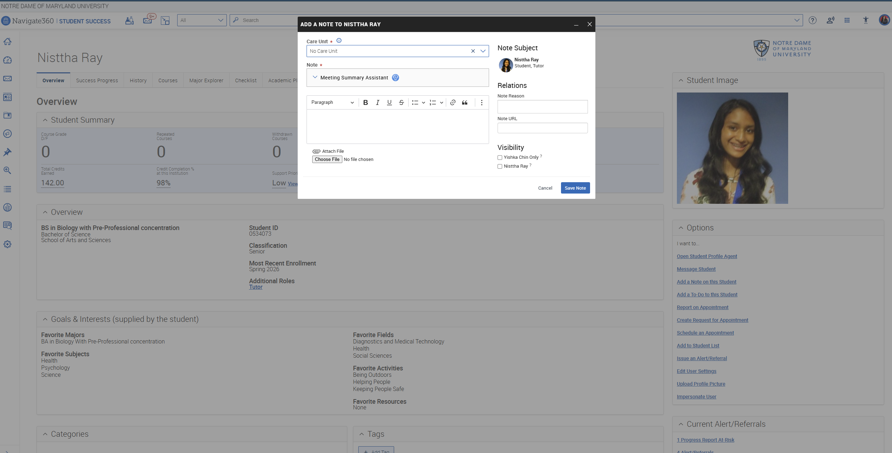

7. Issuing Alerts
- Open the student profile.
- Click 'Issue Alert'.
- Select the concern type.
- Add comments and submit the alert.
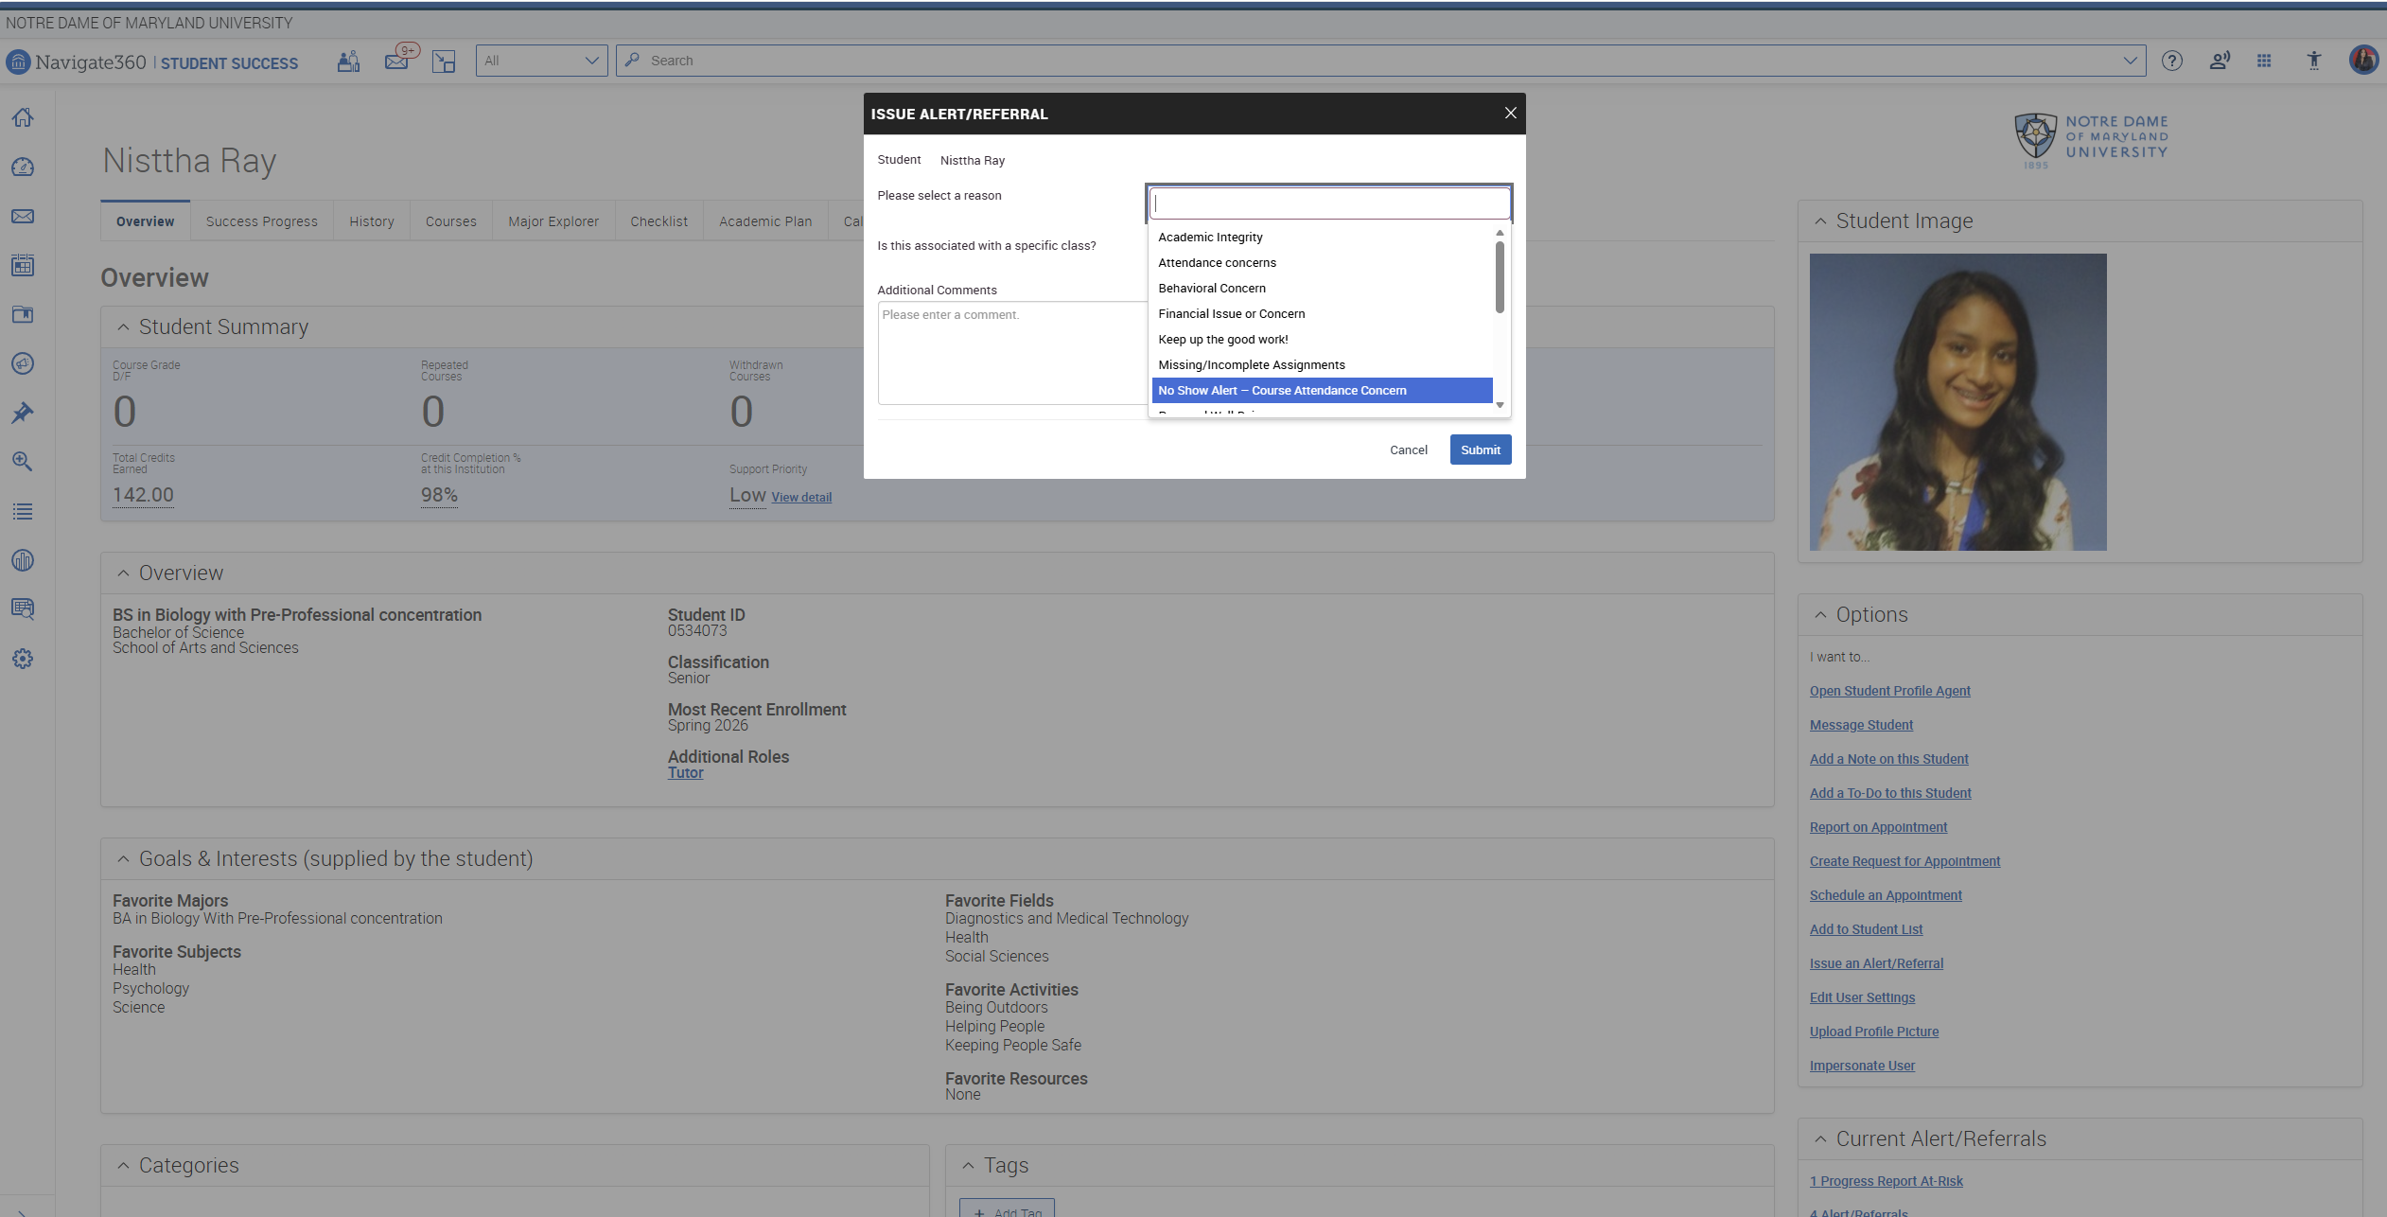

8. Messaging Students
- From the student profile, click 'Message Student'.
- Choose email or text messaging.
- Write the message or click on Apply template to choose from one of the uploaded messaging templates.
- Upload any attachments (If applicable).
- Click Send.
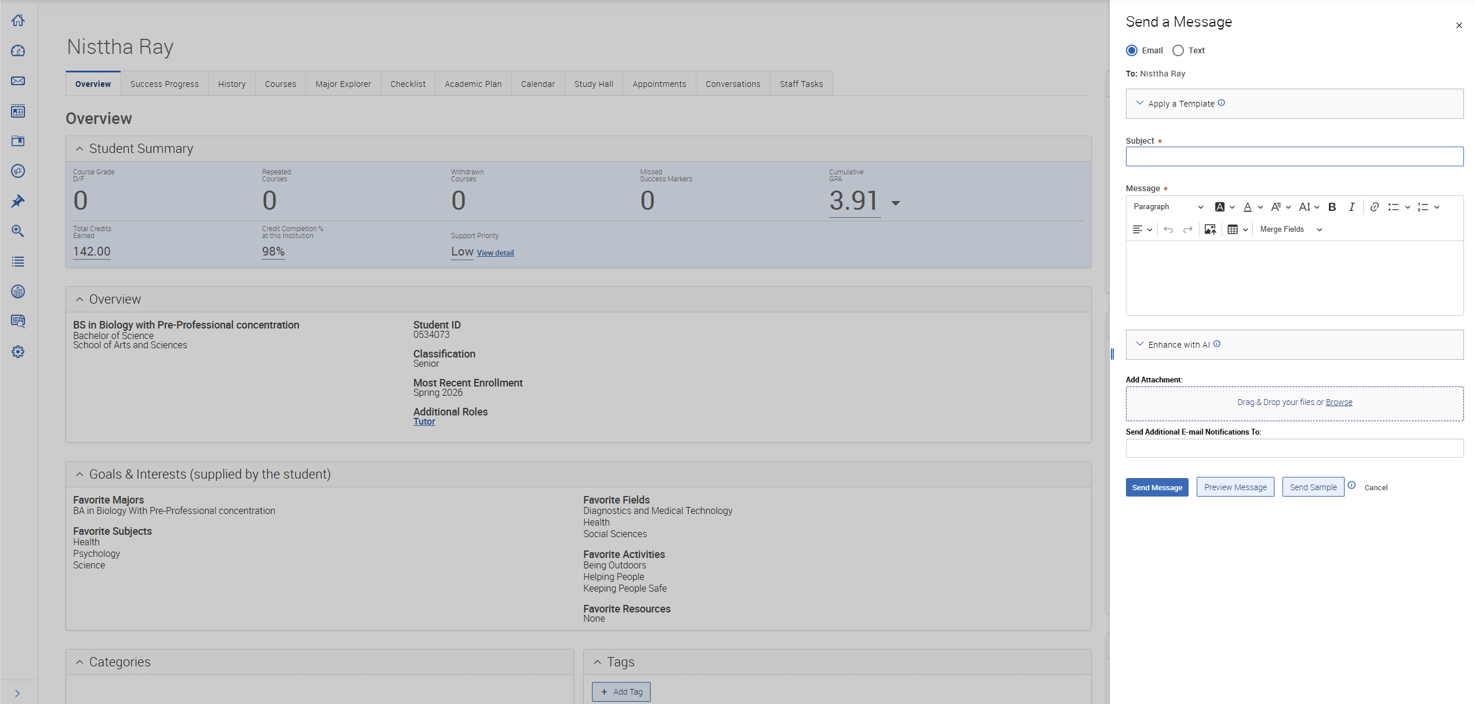

9. Helping Students Register for Classes
- Review the student's academic plan.
- Identify required courses.
- Recommend courses to the students or create a plan to send them directly to the student.
- Encourage the student to register through the student portal.
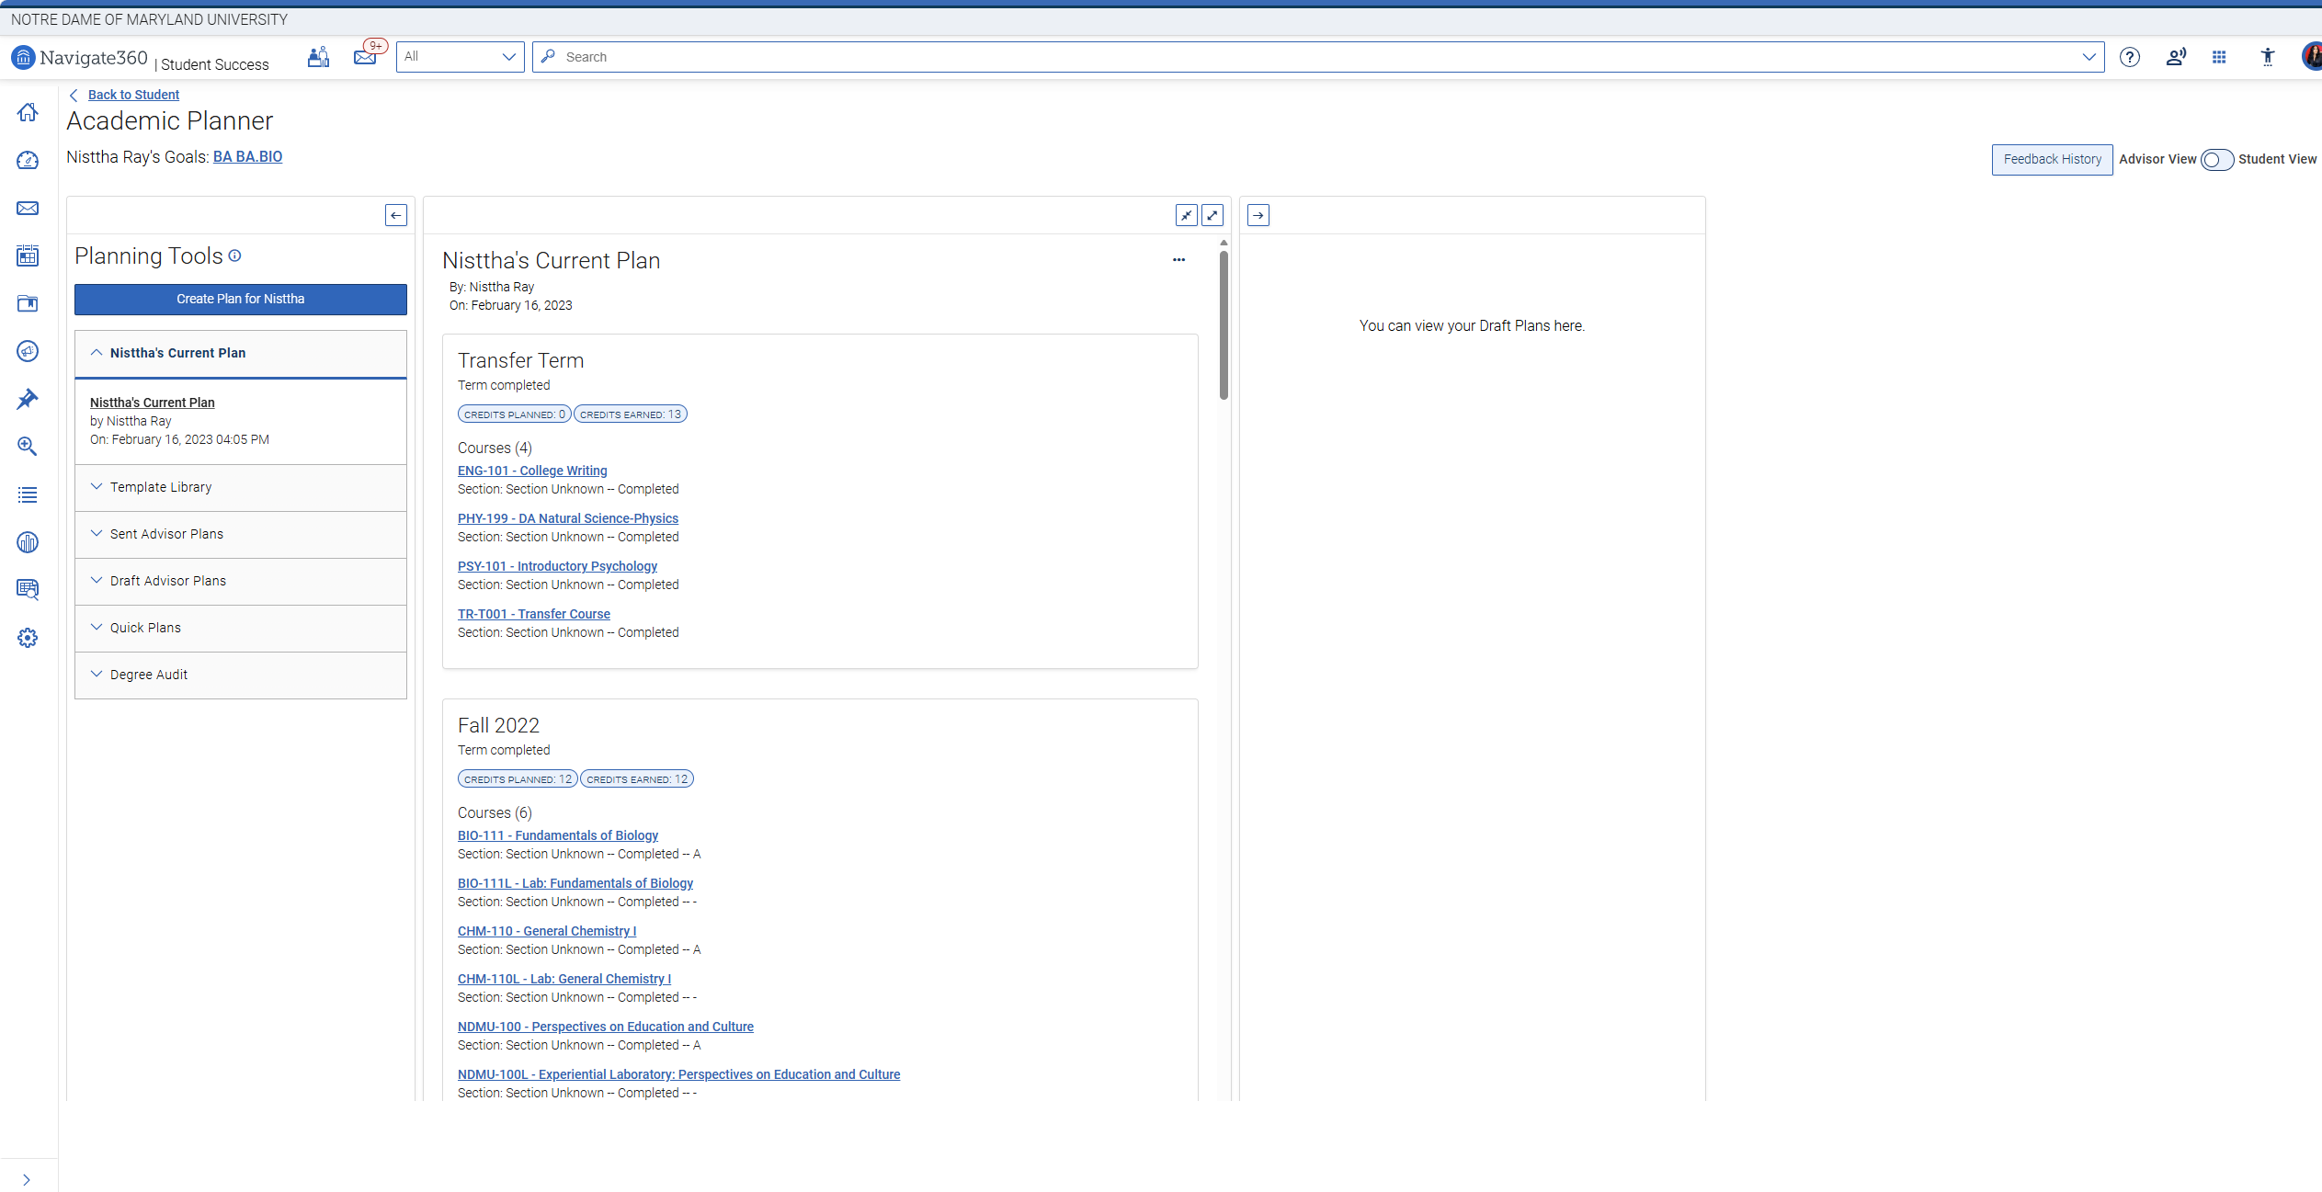

10. Advising Workflow Guide
- Student schedules appointment
- Advisor reviews student profile and academic progress
- Advisor meets with student
- Advisor documents advising notes
- Advisor recommends courses or campus resources
- Advisor follows up with email or message

12. Navigate Training Facilitator Guide
Use this section when training new advisors or staff.
- Begin training by introducing the purpose of Navigate360.
- Show the Staff Home dashboard and explain navigation tools.
- Demonstrate how to search for a student.
- Walk through scheduling an appointment.
- Show how to document advising notes.
- Explain alerts and how they trigger support services.
- Practice sending a message to a student.

Advisor Quick Reference Sheet
Task | Navigate Location
Search Student | Search bar
Assigned Students | Students tab
Schedule Appointment | Student Profile
Add Advising Note | Student Profile → Add Note
Issue Alert | Student Profile → Issue Alert
Send Email/Text | Student Profile → Message Student

Best Practices for Advisors
- Document every advising interaction.
- Use alerts early when concerns arise.
- Follow up with students after meetings.
- Encourage students to use Navigate for appointments.
- Collaborate with other campus support teams.

