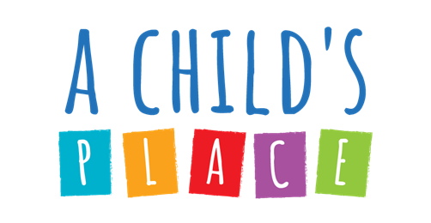

A Child’s Place Parent Handbook
Addendum
for
COVID-19
Updated 11/2022

I have received and read A Child’s Place Parent Handbook Addendum. I understand and agree to abide by the policies and
procedures outlined within.

____________________________________
Child’s Name
__________________________________________________________
Parent/Guardian Signature Date
__________________________________________________________
Print Name

Definitions and Guidance for COVID Protocols
Definition: Close Contact
A close contact is someone who had 15 minutes or more of close contact with an individual who tested positive within the 48-hour period prior to the confirmed positive test result or a potential contact who tested positive for COVID.
Definition: Isolation
Isolating is the procedure completed when someone tests positive for COVID-19.
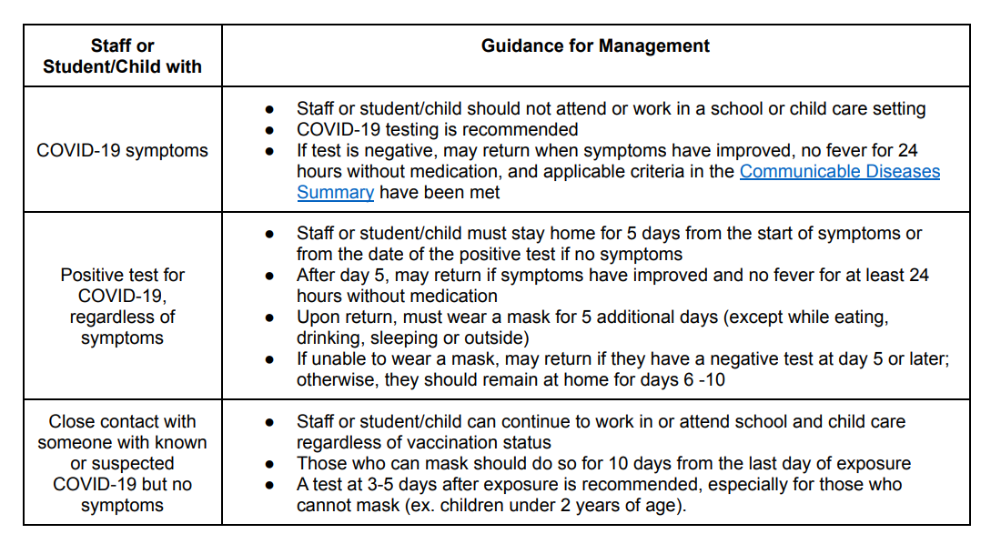
Resource: Communicable Disease Summary
https://health.maryland.gov/mmcp/epsdt/healthykids/Documents/Communicable_Diseases_Fact_Sheet.pdf
o If there is a confirmed case of COVID within ACP, your child may be identified as a close contact.
o You should self-monitor for symptoms and test for COVID-19 on day 3-5 of exposure.
O The first day of isolation is defined as the first full day after the confirmed positive COVID test result.
Confirmed COVID Positive Isolation
o If your child tests positive for COVID-19, they will be asked to isolate for five days. The date of the first symptoms or the positive test is considered day zero. A mask must be worn for five additional days (see above). If a mask cannot be worn, the individual will isolate for a total of ten days.
o Timestamped antigen tests results must be presented to ACP staff upon the morning of child’s return to ACP.
A Child's Place COVID-19 Policies & Procedures
Currently, we are offering year-round open enrollment. We are carefully in step with CDC, Maryland Department of Health, and Baltimore City Health Department guidelines and will be sure to make you aware if something changes that prohibits or recommends a change in our programming plans.
Notre Dame of Maryland University (“NDMU” or “the University”) adheres to federal, State, and Baltimore City COVID-19 related laws, regulations, and health guidelines and if for any reason the University makes the decision not to allow in-person programming, payment will be fully refunded on a pro-rated basis if activities have already begun.
In response to the COVID-19 Pandemic, A Child’s Place has put new policies and procedures in place based on CDC Childcare recommendations, guidance from MSDE and the Office of Child Care, and the Department of Health. These precautions are necessary to reduce the risk of spreading the virus in our preschool community. Due to the nature of this pandemic, this is a dynamic document that will be updated as regulations and guidelines change.
Travel Policies
All students travelling outside of the United States or United States territories are required to test for COVID-19 on day three and five of their return and present a negative test before returning to ACP.
The CDC recommends that screening testing be considered when COVID-19 Community
Levels are moderate or high. Screening testing can also be considered for high-risk activities
such as indoor sports and some extracurricular activities, returning from scheduled breaks, prior
to large gatherings/events, and for staff serving students/children who are at high risk for getting
very sick with COVID-19. As feasible and as resources allow, screening testing can be
performed using point of care rapid antigen tests, RT-PCR tests sent to a laboratory, and/or
through the use of at-home rapid antigen tests. ACP has a limited supply of rapid antigen tests available to families.
All policies are subject to change according to CDC and Office of Child Care guidelines
Staff
- When A Child’s Place reopened, returning staff were required to be fully vaccinated and present a negative COVID-19 test result prior to returning to campus. If a staff member were to test positive at any point in the school year, they would not be allowed on campus until cleared. Staff follow University COVID-19 protocols which may be found here: Testing, Quarantine, & Isolation | Notre Dame of Maryland University (ndm.edu)

- To protect the health and welfare of staff and children, and to mitigate the severity of COVID, ACP requires all staff to be up-to-date on their COVID-19 vaccinations and boosted, and have received the annual influenza vaccine, unless religious or medical illness prevents them from taking a vaccine.

If Your Child or a Staff Member Exhibits Symptoms While at A Child’s Place
- If your child exhibits a fever of 100.4 or more, or any of the other possible COVID-19 symptoms while at school, we will contact you and ask that your child be picked up from school within 30 minutes of notification.
When a Staff Member Exhibits Symptoms or is Diagnosed with COVID-19
  - A staff member with a fever will be sent home immediately and required to seek a COVID test or medical attention.
  - Staff members that test positive for COVID-19 must Self-Report as soon as possible and self- isolate for the duration of their illness. Contact tracing will commence.
  - Ending isolation if you had symptoms – Staff may end isolation after five days if they are fever free for 24 hours (without the use of fever-reducing medication); their symptoms are improving; and they test negative via a COVID-19 antigen (i.e. rapid) test on day five. If positive, continue isolation through day 10.
  - Ending isolation if you did not have symptoms – Staff may end isolation after five days if they test negative via a COVID-19 antigen (i.e. rapid). If positive, continue isolation through day 10.
  - The director must report all positive cases, staff or student, to the NDMU COVID response team, NDMU human resources, Maryland Office of Child Care, Maryland Health Department, Baltimore City Health Department, and child care licensing office.
  - If staff is up-to-date on COVID-19 vaccinations and a close contact, they should self-monitor for symptoms and test for COVID-19 on day five of their potential exposure.
COVID-19 Response to Diagnosis
- If a staff member or child is diagnosed with COVID-19, that classroom will be closed and sanitized. The families of the other children in that classroom will be notified of possible exposure and asked to self-monitor.
- NDMU/ACP will notify local health officials, staff, and families immediately of any case of COVID-19 while maintaining confidentiality as required by the Americans with Disabilities Act (ADA), Federal Education Rights and Privacy Act (FERPA), and CDC Best Practices for Contact Tracing. ACP will contact designated parents via phone and email.
- For Contact Tracing, ACP will contact designated parents via phone and email.
Preschool Environment and Social Distancing
- Classrooms are organized into cohorts to be separate and distinct learning spaces with no shared learning objects. Each classroom has the same teacher all day every day, with the possible exception of lunch and bathroom breaks when an assigned floater teacher will relieve the lead teacher.
- Sleeping cots will be spaced out to allow social distancing and head-to-toe positioning.
- Each classroom will have daily opportunities to take learning outside, not just for gross motor activities, but also for regular class activities and experiential learning activities.
- New purifying air filters have been installed in each classroom. A Nu-Calgon 4900-20 - iWave- R Self-Cleaning Bi-Polar Ionization ION Generator has been mounted on the inside of the air handling unit in each room.

Face Coverings (Optional)
- All children and staff will have the option of wearing a face covering, but will no longer be required, unless the status of COVID-19 transmission as determined by CDC recommendations reaches a “high” status.
- Children or adults who opt to wear cloth facemasks will take home their facemasks each day for cleaning.
- Children or adults who opt to wear disposable facemasks should have a ready supply in their cubbies or classrooms.
- ACP will maintain a supply of facemasks/coverings on location (cloth and disposable) in the event of damage, contamination, or emergency need, in both children’s and adult sizes.
Health Checks
- ACP has established routine, daily health checks upon arrival of both staff and children. Parents are required to let ACP staff know if their child has any symptoms of COVID 19.
- Parents are required to keep sick children home. Do not provide your child with fever reducing medicine.
- ACP will monitor absences of children and staff to identify patterns or trends in illnesses and absences.
Visitors in the Building
- Parents and family members may enter ACP for morning and afternoon pick up.
- Visitors, volunteers, or activities involving other groups in the preschool space will be limited, and individuals will be requested to be up-to-date on COVID-19 vaccination.
- Any special needs support services staff will be allowed in the Center.
- Touring A Child’s Place will be arranged in advance. Visitors will be asked if they have had any symptoms of COVID 19 in past 2 weeks.
Drop Off and Pick Up Procedures
  - Morning drop off will return to pre-COVID procedures
    - Parents will walk students to the Big Room at arrival and sign them in on the clipboard.
  - Afternoon drop off will return to pre-COVID procedures
    - Parent will enter the building to pick up their child. Parents will sign students out on the clipboard located in the Big Room.
Children’s Cubbies
- Each child will have their own labelled space for their belongings. Their personal belongings will be separated from other students’.
Bedding
- Children’s bedding will be sent into school every Monday the child’s name on it.
- To prevent cross contamination from one child’s bedding to another, a staff person will place the bedding in an extra-large plastic bag with your child’s name on it for storage during the week.
- The teacher will store the child’s bedding back in the plastic bag after nap time.
- All bedding will be sent home on Fridays to be laundered and returned to school on Monday.
- Most children appreciate having a ‘lovey’ or small soft toy of their own to have with them during nap time. This item may be stored with the bedding or taken home each day.
Direct Contact with Children
- To prevent the risk of transmitting COVID-19, staff and students will be educated and trained to discourage immediate contact, i.e., shaking hands, holding hands, or hugging. Other forms of greeting shall be introduced, e.g., waving, thumbs up, peace sign, air hug, saying “hello” in sign language, and more.
Hand Hygiene and Other Healthy Habits
- Hand sanitizer will be available at the entrance of A Child’s Place so that children can clean their hands with hand sanitizer before they enter. They also may wash their hands in a sink upon entry to the classroom.
- ACP staff will continue to teach and reinforce washing hands and covering coughs and sneezes among children and staff.
- Hand washing/hand hygiene will occur for all children and staff upon arrival and frequently throughout the day.
Bathroom Usage
- Only one child may go into the classroom bathroom at a time.
- The common bathroom in the hallway will also be used by the classrooms, and children will always be accompanied by a staff person.
Access to Drinking Water
- ACP has taken steps to utilize rented water coolers for each classroom for drinking use.
- The preschool water fountain has been disconnected.
- Students are asked to bring a reuseable water bottle each day.
Meals and Snacks at ACP
- Parent are required to send their children’s daily lunch into the preschool in lunch boxes or hard containers with the child’s name.
- A staff member will place cold lunches in the refrigerator each day.
- Families also have the option to purchase a warm lunch through the NDMU (SAGE) dining hall in Doyle Hall for the cost of $6.50 per day. Orders must be placed on a monthly basis, and are not available on a daily or weekly basis. Lunches must be ordered and paid for in advance along with monthly tuition.
- Purchased lunches will be picked up by a staff member ahead of lunch time. Sage Dining Services possesses a food safety certificate from the DOH.
- ACP will continue to provide milk and snacks. Parents may also send a milk alternative into the school for their child if their child is not able to consume cow’s milk. Please label this product.
- No food sharing will be allowed, no home-baked birthday cakes or home baked items will be permitted into the center to be shared. Purchased food items in their original containers may be permitted after approval from the Director.

Cleaning and Disinfecting in ACP
- A supply of cleaning supplies will be maintained at A Child’s Place, including Lysol Disinfectant spray, Clorox, wipes, hand sanitizer, etc.
- Soap and water and a bleach and water solution will be used in the classrooms for high touch areas throughout the day as directed by the Office of Child Care.
- Following guidelines of OCC, CDC, and the EPA, cleaning and disinfecting will be done multiple times per day, in a safe manner, away from children.
- After children and teachers have left ACP for the day, staff of the NDMU Facilities Department will facilitate a complete evening cleaning and disinfecting of the preschool.
- Periodic deep cleaning will be ordered and conducted as necessary using the University Facilities.

